第一届AAPG圈层相互作用与深层油气国际学术会议
AAPG International Research Symposium on Interaction between Earth’s Spheres and Deep Oil and Gas
（三号通知）

向地球深部进军是我们必须解决的战略科技问题。深层油气是保障国家油气安全最重要的领域之一，深层油气富集理论与高效勘探开发技术创新既是油气资源可持续开发利用的基础，也是全球科技竞争的前沿。立足地球系统科学和圈层相互作用思想，多单位协同、多学科交叉是实现科技创新的必要途径。2023年中国石油大学（华东）依托深层油气全国重点实验室牵头成立了深层油气创新联盟，引领了深层油气勘探开发理论与技术创新，得到了美国石油地质家协会（AAPG）的高度关注。为进一步推动深层油气领域的学术交流、科技合作和文化创新，中国石油大学（华东）和AAPG共同打造深层油气领域高端国际交流平台——“圈层相互作用与深层油气（IES-DOG）”国际学术会议。会议主题聚焦“深层油气富集机理与高效勘探开发”，旨在汇聚全球地质学家智慧，交流基于圈层相互作用理论认识深部油气资源分布的最新成果，探讨深层油气勘探开发新理论、新技术，推动油气工业的可持续发展。
第一届AAPG圈层相互作用与深层油气国际学术会议将于2025年10月24日至27日在山东省青岛市中国石油大学（华东）召开。自通知发出后，得到了高校、科研院所和油田生产单位等社会各界的广泛关注和积极响应。
大会组织委员会按专题分组审阅了全部论文摘要，已经遴选出会议大会报告、分会场报告和展板报告，讨论决定了大会各项议程等相关事宜，现将有关事项通知如下：

一、会议主题
深层油气富集机理与高效勘探开发
二、组织机构
（一）组织单位
1.主办单位
深层油气全国重点实验室
美国石油地质家协会（AAPG）
中国石油超深层复杂油气藏勘探开发技术研发中心
中国-沙特石油能源“一带一路”联合实验室
2.承办单位
中国石油大学（华东）
中国石油化工股份有限公司勘探分公司
中国石油集团工程技术研究院有限公司
中国石油天然气股份有限公司塔里木油田分公司
（二）指导委员会
主 席：马永生 Thomas Wilker（AAPG总裁）
副主席：朱日祥 贾承造 袁士义 孙龙德 金之钧 赵文智 李 阳 彭平安
郭正堂 杨树锋 刘 合 邹才能 徐义刚 郭旭升 谢玉洪 孙焕泉
张水昌
Herman Darman (AAPG亚太区主席) Derek Elsworth (美国工程院院士)
Kliti Grice (澳大利亚科学院院士) Brian Horsfield (德国工程院院士)
Zhengxiang Li（澳大利亚科学院院士）
Yanghua Wang (英国皇家工程院院士、中国工程院外籍院士)
（三）学术委员会
主 席：孙金声
副主席：王香增 支东明 田立新 付晓飞 匡立春 刘可禹 刘树根
刘勇胜 刘清友 江同文 李国欣 李建威 吴怀春 金 衍
周立宏 赵贤正 徐长贵 郭彤楼 郭建春 曹 宏 窦立荣
Geoffrey Ellis, Boris Gurevich, Peter Grant, Hossein Hejazi
Helge Hellevang, Tako Koning, Brent McInnes, Raymond Michels
Vamegh Rasouli, Klaus Regenauer-Lieb, Alaa Salem, Tristan Salles
Hans-Martin Schulz, Hebert Volk, Sabin Zahirovic, Carlos Zavala
（四）组织委员会
主 席：郝 芳 Susan Nash (AAPG新兴科技与创新部总监)
副主席：王良军 刘绪全 杨海军
三、会议专题
（一）板块运动与盆地形成演化
召集人：朱日祥、Zhengxiang Li、杨海军、倪怀玮
（二）多圈层相互作用与深层油气富集
召集人：郝 芳、Kliti Grice、王良军、刘可禹
（三）岩石圈演化与清洁能源资源
召集人：金之钧、Geoffrey Ellis、许天福、刘全有
（四）高温高压岩石物理与深层油气智能预测
召集人：Yanghua Wang、Boris Gurevich、宋强功、符力耘
（五）深层油气安全高效钻井与低碳开发
召集人：孙金声、Vamegh Rasouli、汪海阁、王志远
（六）AI技术与深层油气勘探开发
召集人：刘 合、Stefan Iglauer、肖倚天、杨永飞
四、会议时间、地点
会议时间：2025年10月24日—27日，24日报到
报到地点：青岛康大豪生大酒店
会议地点：中国·青岛 中国石油大学（华东）

五、大会报告
Detailed Conference Program
Saturday, October 25
Opening Plenary Session
Venue | Second Floor, Yifu Conference Center
Time | 8:30-18:05, October 25, 2025
Chair: Qiangming Wu
8:30-8:55 | Opening Remarks
Chair: Yongsheng Ma
8:55-9:20 | Chengzao Jia | The Whole Petroleum System Theory and Its Exploration Practice
9:20-9:45 | Longde Sun | Exploring Oil and Gas Beyond 10,000 m Depth in China
9:45-10:10 | Coffee Break & Group Photo
Chairs: Thomas Wilker, Pingan Peng
10:10-10:35 | Fang Hao | Coupling and Interactions of Earth's Spheres: Climate–Carbon Cycle Feedbacks and Their Controls on Source Rock Types and Distribution
10:35-11:00 | Hans-Martin Schultz | Oil-water Contacts: When Reactive Interfaces Control Oil and Rock Properties
11:00-11:25 | Zhengxiang Li | A Geodynamic Framework for 2 Billion Years of Tectonic Evolution: From Cratonic Amalgamation to the Age of Supercontinent Cycle
11:25-11:50 | Brent McInnes | Exploration at the Edge of the Arc: Active Seepage and Petroleum System Dynamics in the Frontier New Ireland Basin, Papua New Guinea
11:50-14:00 | Lunch Break
Chairs: Brent McInnes, Xiaofei Fu
14:00-14:25 | Jinsheng Sun | CNPC's 10,000-Meter Ultra-Deep Drilling: Technological Advances and Future Prospects
14:25-14:50 | Vamegh Rasouli | Rock Physics Modeling of CCUS
14:50-15:15 | Xusheng Guo | Advances and Prospects in Deep to Ultra-Deep Natural Gas Exploration
15:15-15:40 | Muhammad Shahzad Kamal | Innovative Chemical Solutions for Challenging High-Temperature and High-Salinity Upstream Applications
15:40-16:00 | Coffee Break
Chairs: Shufeng Yang, Helge Hellevang
16:00-16:25 | Tobias M. Müller | Seismic Waves, Poroelastic Deformation and the Change of Porosity
16:25-16:50 | Haijun Yang | New Petroleum Geological Understanding of Ultra-Deep Carbonate Reservoirs: Insight from the Take-1 >10 km Deep Drilling in the Tarim Basin
16:50-17:15 | Zhijun Jin | Research Progress and Prospects of Natural Hydrogen
17:15-17:40 | Raymond Michels | Hydrogen in the Carboniferous Basin of Lorraine (France): Toward a “Hydrogen System” Model (online)
17:40-18:05 | Herman Darman | Outlook of AAPG Asia Pacific Region (online)

Sunday, October 26
Topic 1
Plate Tectonics and Basin Formation and Evolution
Chairs: Bo Wan, Huaiwei Ni, Hongyan Li, Haijiang Zhang Secretary: Fanchao Meng
Venue | Room D207, Education Development Center
Time | 8:30-17:25, October 26, 2025

8:30-8:50 | Hanlin Chen | Keynote: The Basin Prototypes and Subsequent Modification of the Deep Stratigraphic Sequences in the three Major Cratons of China
8:50-9:10 | Sanzhong Li | Keynote: Proto-Tethys Ocean and Microplates
9:10-9:25 | Yangwen Pei | Spatial and Temporal Evolution and Petroleum Significance in the Sichuan Basin, SW China
9:25-9:40 | Kabir Shola Ahmed | An Overview of the Framework, Structural Geology, and Petroleum Geology Aspects of the West, Central, and East African Rift System
9:40-9:55 | Wuke Chen | Sedimentary Sequences of the Nanhua System Controlled by Rift Structures and Implications for Deep Hydrocarbon Exploration in the Northern Margin of the Yangtze Block
9:55-10:15 | Coffee Break
10:15-10:35 | Jianping Zheng | Keynote: Subduction and Retreating of the Western Pacific Plate Resulted in Lithospheric Mantle Replacement and Coupled Basin-mountain Respond in the North China Craton
10:35-10:55 | Haijiang Zhang | Keynote: Cenozoic Destruction of Eastern North China Craton Evidenced by Seismically Imaged Lithosphere Delamination and Nd Isotopes
10:55-11:10 | Fengqi Zhang | Tectonic Evolution of the Tarim Craton from the Proterozoic to the Paleozoic: Supercontinent Cycles and their Impacts on Basin Development
11:10-11:25 | Hafiz Ahmed Raza Hassan | Complex Tectono-Stratigraphic Interactions and Their Impact on Petroleum Systems from Shallow to Deep Water in the Offshore Indus Basin
11:25-11:40 | Qiang Zhang | Tectonic Evolution and Fracture Characteristics of Mesozoic Volcanic Buried Hills in Bozhong Sag, Bohai Bay Basin
11:40-14:30 | Lunch Break
14:30-14:50 | Bo Wan | Keynote: Anoxic Equatorial Tethys Ocean and Its Magmatic-Metallogenic Implications
14:50-15:10 | Huaiwei Ni | Keynote: Formation and Evolution of Supercritical Geofluids
15:10-15:25 | Lauben Twinomujuni | Geological Development and Hydrocarbon Prospectivity of the East African Rift System: Insights from the Albert Rift, Uganda
15:25-15:40 | Yu Cao | Tectono-Sedimentary Evolution in the Late Triassic North Qiangtang Basin: Response to Closure of the East Paleo-Tethyan Ocean
15:40-15:55 | Tianhai Huang | Permo-Triassic Transition Collision between the South and North China Block in the Upper Yangtze Region: Implications for the Developments of Marginal Rifts
15:55-16:15 | Coffee Break
16:15-16:35 | Hongyan Li | Keynote: Formation Timing and Geological and Environmental Implications of the East Asia Big Mantle Wedge
16:35-16:55 | Peng Gao | Keynote: Identifying the Role of Water in Crustal Melting from the Perspective of Granite
16:55-17:10 | Ruiwen Huang | Paleosalinity Evolution of the Paleo-large Lake During the Depositional Periods of the Yaxicuo and Wudaoliang Formations in the Tuotuohe Basin and Its Response to the Tibetan Plateau Uplift
17:10-17:25 | Yibo Li | Quantifying Tectonic Loading and Lithospheric Strength on Foreland Basin Evolution: A 2D Flexural Modeling Study from the Sichuan Basin

Topic 2
Earth’s sphere Interactions and Deep Hydrocarbon Enrichment
Chairs: Rui Fan, Hans-Martin Schultz, Guangyou Zhu, Saju Menacherry Secretary: Shang Xu
Venue | Room D205, Education Development Center
Time | 8:30-17:40, October 26, 2025

8:30-8:50 | Jian Cao | Keynote: Organic–Inorganic Interactions of Hydrocarbon Generation of Saline Lacustrine Source Rocks: Implications for Deep Oil Potential
8:50-9:10 | Saju Menacherry | Keynote: Impact of Diagenetic Processes on Reservoir Quality in Deep-Buried Sandstones of the Triassic Mungaroo Formation, Northern Carnarvon Basin, Australia
9:10-9:25 | Guanghui Yuan | Water Microdroplets: Microreactors for Organic-Inorganic Interactions in Geosystems
9:25-9:40 | Aizimaiti Maimaiti | Reconstruction of Multi-source and Multi-stage Hydrocarbon Accumulation History in the Tarim Basin: Constraints from Fluid Inclusions and in Situ Calcite U-Pb Dating
9:40-9:55 | Jianhua Dong | Identification of a Permian Volcanic Paleo-Uplift in the Western Sichuan Basin and its Implications for Paleogeomorphic Evolution
9:55-10:15 | Coffee Break
10:15-10:35 | Xiaofei Fu | Keynote: Sealing and Safe Operation of Deep Underground Gas Storage
10:35-10:55 | Hui Tian | Keynote: Hydrothermal Fffects on the Heterogeneity and Thermal Maturity Evaluation of Ediacaran Pyrobitumen in Central Sichuan Basin
10:55-11:15 | Tao Zen | Keynote：Hydrocarbon Accumulation Process and Exploration Implications of the Ultra-Deep Dengying Formation in the Northern Sichuan Basin
11:15-11:30 | Qiang Hu | Preservation Mechanisms of Deeply-Buried High-Quality Clastic Reservoirs in the Zhengshacun area, Junggar Basin, NW China
11:30-11:45 | Zhifang Li | Multi-Scale Constraints on the Ultra-Deep Oil Charging History of the Upper Cambrian in the Xiongtan Area, Western Tabe I: Evidence from Carbonate U-Pb Dating and Fluid Inclusions
11:45-12:00 | Hao Tang | The Strike-Slip Fault Controlled Model on the Ultra-Depth Reservoir and Hydrocarbon Accumulation in Halahatang Oilfield, Tarim Basin
12:00-14:30 | Lunch Break
14:30-14:50 | Guangyou Zhu | Keynote: Integrated Discoveries from Three Global Ultra-Deep Wells Beyond 10 km
14:50-15:10 | Huajian Wang | Keynote: Formation of Paleozoic Source Rocks and Their Contribution to Deep and Ultra-Deep Oil and Gas in the Southwestern Tarim Basin
15:10-15:25 | Haiping Huang | Integrated Discoveries from Three Global Ultra-Deep Wells Beyond 10 km
15:25-15:40 | Huan Li | Reevaluation of and New Knowledge on the Influences of Grain-Coating Clay Minerals on Sandstone Diagenesis
15:40-15:55 | Nida Sundhu | Stratigraphic Forward Modelling of an Eocene Carbonate platform in the Laki Range, Lower Indus Basin, Pakistan: Manifestation of Tectonic and Hyperthermal Climatic Changes
15:55-16:15 | Coffee Break
16:15-16:35 | Fujie Jiang | Keynote: Multi-Spheric Interactions and Hydrocarbon Enrichment of the Ordos Basin
16:35-16:55 | Yunpeng Wang | Keynote: Multi-sphere Control of the Development and Distribution of Cambrian Source Rocks in the Tarim Basin
16:55-17:10 | Linchi Jiang | Determinants of High Gas Content and Restoration of in Situ Gas Content in the Permian Wujiaping Shale of the Eastern Sichuan Basin, China
17:10-17:25 | Xin Yang | Formation Mechanisms of Ultra-Deep Gas Condensate Reservoirs: A Case Study of the Shunbei No. 4 Strike-Slip Fault Zone in the Tarim Basin
17:25-17:40 | Zhehang Xu | Impact of Stylolitization on Deep Microbial Dolomite Reservoirs of the Terminal Ediacaran Dengying Formation in Central Sichuan Basin, Southwest China

Topic 3
Lithosphere Evolution and Clean Energy Resources
Chairs: Quanyou Liu, Xiaomei Wang , Helge Hellevang Secretary: Guanghui Yuan
Venue | Room D202, Education Development Center
Time | 8:30-12:00, October 26, 2025

8:30-8:50 | Helge Hellevang | Keynote: Natural Hydrogen and Transport Properties
8:50-9:10 | Xiaomei Wang | Keynote: Multi-pathway Generation Mechanisms of Natural Hydrogen and Genetic Sources in Typical Sedimentary Basins
9:10-9:25 | Qingqiang Meng | Primary Exploration Progress for Natural Hydrogen in South China
9:25-9:40 | Qingyong Luo | Application of Molecular Simulation Technology in the Helium Accumulation
9:40-9:55 | Ping Li | The Controlling Factors on the Release of Helium from Rocks: Chemcial Species of Uranium and Thorium
9:55-10:15 | Coffee Break
10:15-10:35 | Quanyou Liu | Keynote: Formation and Accumulation of Precious Gas in Sedimentary Basins
10:35-10:55 | Shu Jiang | Keynote: Deep Geodynamics and Multi-Energy Accumulation in Fine-Grained Reservoirs
10:55-11:15 | Renbiao Tao | Keynote: Natural Hydrogen Generation via Partial Hydration of the Metamorphic Basement in the Ordos Basin
11:15-11:30 | Hui Wu | Technical Challenges in Harnessing Earth's Geothermal Energy and Potential Solutions
11:30-11:45 | Chengsheng Chen | Quantifying Radiogenic Helium From Mantle Volatiles in the Diapiric Structures in the South China Sea and Its Implication For Earth’S Sphere Interactions
11:45-12:00 | Ziqi Feng | Origin and Accumulation Mechanisms of Helium in the Context of Deep Thermal Fluid Activity

Topic 4
HTHP Rock Physics and Intelligent Prediction of Deep Hydrocarbons
Chairs: Liyun Fu, Danping Cao, Tongcheng Han Secretary: Jidong Yang
Venue | Room D204, Education Development Center
Time | 8:30-15:10, October 26, 2025

8:30-8:50 | Xiangyun Hu | Keynote: Borehole-Surface Electromagnetic Imaging and Its Application in Deep Reservoir Oil Detection
8:50-9:10 | Yun Wang | Keynote: Tensor Seismics
9:10-9:25 | Tongcheng Han | Understanding the Effects of Temperature on the Joint Elastic-Electrical Properties of Sandstones
9:25-9:40 | Feng Zhang | Estimation of Reservoir Parameters Using Seismic Shear Wave
9:40-9:55 | Wubing Deng | A Poroelastic Vibroseis Model for Enhanced Near-Surface Simulation
9:55-10:15 | Coffee Break
10:15-10:35 | Weijian Mao | Keynote: Scattering Migration and Inversion for Acoustic VTI Media
10:35-10:55 | Hua Wang | Keynote: Beyond the Spatial Sampling Limit: A Physics-Informed Intelligence Approach to Full-Wavefield Decoupling in Boreholes
10:55-11:10 | Yikang Zheng | Characterizing CO₂ Plumes in Deep Saline Formations with Time-Lapse Seismic Monitoring
11:10-11:25 | Zhonghui Tu | Factors Influencing Permeability of Fractured Reservoirs Under Anisotropic Stress
11:25-11:40 | Jiecheng Song | Evaluation of Rock Mechanical Properties and Production Pressure Differential in Underground Gas Storage Under Multi-Cycle Injection/Production Conditions
11:40-11:55 | Yilin Liang | A Study on Rock Damage Mechanics and Wave Equation Modeling
11:55-14:30 | Lunch Break
14:30-14:50 | Xuri Huang | Keynote: Seismic Imaging and Identification Methods for Deep Targets
14:50-15:10 | Danping Cao | Keynote: Seismic Attenuation Characterization and Application With Viscoelastic Wave Equation

Topic 5
Safe and Efficient Drilling and Low-Carbon Development of Deep Oil and Gas
Chairs: Zhiyuan Wang, Wei Guo Secretary: Xueyu Pang
Venue | Room D206, Education Development Center
Time | 8:30-12:10, October 26, 2025

8:30-8:50 | Wei Guo | Keynote: Experimental Study and Pilot Tests of Autothermic Pyrolysis in Situ Conversion Process for Oil Shale Recovery
8:50-9:10 | Congfeng Qu | Keynote: Advances and Challenges in Cementing Technology
9:10-9:30 | Yongcun Feng | Keynote: Optical Fiber Monitoring of Cement Sheath Integrity
9:30-9:45 | Hao Zhang | Interpretable Machine Learning for Identifying Driving Mechanisms and Predicting Fracture Pressure in Shale Reservoirs
9:45-10:00 | Kalonji Gradi Lelo | Structure Design and CFD Simulation of a Negative Pressure Activated Drill String Vibration Tool
10:00-10:15 | Coffee Break
10:15-10:35 | Zhiyuan Wang | Keynote: Theory and Technology of Intelligent Well Control under Complex Formation Pressures
10:35-10:55 | Feifei Zhang | Keynote: An Intelligent Well-path Design Approach Based on Probabilistic Roadmap Method for Drilling in Congested Environments
10:55-11:15 | Tianshou Ma | Keynote: Quantitative Risk Assessment for Wellbore Collapse of Inclined Wells in Anisotropic Formations
11:15-11:35 | Weiji  Liu | Keynote: Research and Practice of Improving ROP
11:35-11:55 | Yanzhi Hu | Keynote: Rock Mechanical Properties and Physical Simulation for Ultra-deep Drilling
11:55-12:10 | Yu Lu | Predicting Aqueous-phase Trapping Damage and Classifying Tight Sandstone Reserviors Using MICP

Topic 6
AI Technology and Deep Hydrocarbon Exploration and Development
Chairs: Yongfei Yang, Jianchao Cai Secretary: Tiankui Guo
Venue | Room D208, Education Development Center
Time | 8:30-15:45, October 26, 2025

8:30-8:50 | Yitian Xiao | Keynote: Bridging AI and Geology: The Role of Large Language Models in the Future of Geoscience
8:50-9:10 | Yili REN | Keynote: Research Progress on Intelligent Analysis of Core Images
9:10-9:25 | Yuqi Wu | AI-Driven Digital Rock Technique and Its Applications in Oil Exploration and Development
9:25-9:40 | Mingming Tang | Prospects for Sedimentary Numerical Simulation and Geological Intelligent Agent Applications in the Context of AI Large Models
9:40-9:55 | Zhichao Xie | Aartifical Intelligence Driven Hydrodyanmics Based Deviation Indentification of Field Drilling and Logging Parameters and its Application in Thief Zone Information Diagnosis
9:55-10:15 | Coffee Break
10:15-10:35 | Xinming Wu | Keynote: Geological Everything Model 3D: A Promptable Foundation Model for Unified and Zero-Shot Geologic Interpretation & Modeling
10:35-10:55 | Haoran Cheng | Keynote: AI Driven Constrained Multi-Objective Well-Pattern Optimization for Mature Oilfields
10:55-11:15 | Luanxiao Zhao | Keynote: Physics and Geolog-guided Deep Learning for Seismic Reservoir Characterization
11:15-11:30 | Chao Huang | Characteristics and Enrichment Law of Tight Oil Reservoir In Jishan Sandbody, Huimin SAG
11:30-11:45 | Yunjie Zhang | Application and Prospect of Molecular Simulation in Deep Oil and Gas Research
11:45-14:30 | Lunch Break
14:30-14:50 | Nanzhe Wang | Keynote: "Data+Physics" Driven Deep-Learning Model Applications in Subsurface Energy Development
14:50-15:10 | Yuzhu Wang | Keynote: Challenges in Digital Rock Physics and Possible Mitigation Strategies
15:10-15:30 | Yongzan Liu | Keynote: Quantitative Interpretation of Crosswell Low-Frequency Distributed Acoustic Sensing Data for Hydraulic Fracture Monitoring
15:30-15:45 | Jinding Zhang | Adaptive Surrogate Model Training Method for Efficient Data Assimilation in CO₂ Storage

Student Session
Chairs: Yuanda Su, Xueyu Pang, Tongcheng Han, Bing Yuan
Venue | Room D302, Education Development Center
Time | 8:30-15:30, October 26, 2025

8:30-8:45 | Xinle Zhang | Mechanism Underlying Differences in Hydrocarbon Phase States Within Ordovician Reservoirs of the Fi19 and Fi20 Strike-Slip Fault Zones in the Fuman Oilfield, Tarim Basin
8:45-9:00 | Zhengbin Wu | Pore Structure of Shale Gas Reservoirs and Its Impact on the Migration of Fracturing Fluid
9:00-9:15 | Daomao Lin | Sedimentary Environment and Organic Matter Enrichment Mechanism of the Permian in the Jianggang Area, Lower Yangtze
9:15-9:30 | Junlin Chen | Coupling of Plate Subduction, Tan-Lu Fault, and Mantle Fluids in the Formation of Deep CO₂-Rich Petroleum Systems in Eastern China, Subei Basin
9:30-9:45 | Bo Gao | Shale Oil Content and Movability Threshold in Shahejie Formation, Dongying Depression
9:45-10:00 | Zilong Li | Origin of Bedding-Parallel Fractures and Their Controls on Shale Oil Enrichment in Lacustrine Shales
10:00-10:15 | Coffee Break
10:15-10:30 | Ning Lu | Depositional Mechanisms and 3D Distribution Modeling of Wave- dominated Bar Reservoirs in the second member of the Hanjiang Formation, Enping Sag, South China Sea
10:30-10:45 | Ziming Wang | Geochemical Variability of Lacustrine Shales and Mudstones from the Yanchang Formation, Ordos Basin, China: Insights into Their Sedimentary Environments and Organic Matter Enrichment
10:45-11:00 | Zhihua Lian | Formation and Evolution of Fault-Karst Reservoirs in the Maokou Formation under Tectonic-Sedimentary Coupling
11:00-11:15 | Zhihao Wang | Analcime in lacustrine mudstones as a record of hydrothermal fluids: Insights from the Kongdian Formation, Bohai Bay Basin, China
11:15-11:30 | Hongjiao Li | Constraints on Tectonic Hydrothermal Alteration of Permian Volcanic Rock Reservoirs: Evidence from Fluid Inclusions in Altered Minerals
11:30-11:45 | Bing Tan | Study on Reservoir Characteristics and Formation Model of Ultra-Deep Emeishan Basalt in the Sichuan Basin
11:45-14:30 | Lunch Break
14:30-14:45 | Jiayun Chen | Traveltime-Waveform Joint Full-Waveform Inversion for High-Resolution Velocity Modeling in Deep Reservoirs
14:45-15:00 | Wenzhen Tian | Discovery of Deep Carbonate Strike-Slip Fault-Controlled “Sweet Spots” Gas Reservoirs in Sichuan Basin
15:00-15:15 | Guangyue Zhou | Adapting 2D Visual Foundation Models for 3D Seismic Fault Segmentation

六、参会报名
参会人员请扫码注册报名。
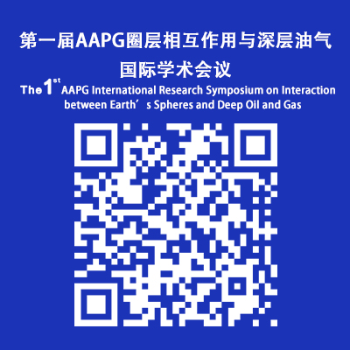
会议注册二维码
七、会议交通及住宿
本次会议不安排接送站，请各位参会代表自行从机场或高铁站至青岛康大豪生大酒店报到参会。交通路线见附件1。
会议协商青岛康大豪生大酒店为住宿酒店，价格360元/间（大床、标间，含双早），特别提示：房源紧张，请参会代表提前进行酒店预定。
酒店预定联系人：安从艳 15866896846
八、会议支持期刊
Energy Science、Advances in Geo-Energy Research、《石油勘探与开发（Petroleum Exploration and Development）》、《中国石油大学学报（自然科学版）》、《天然气工业》、《世界石油工业》
九、会议秘书处及联系方式
秘书长：杨永飞
成 员：孟凡超、徐 尚、远光辉、杨继东、庞学玉、郭天魁
会议工作人员联系方式：张德瑛 19819970701 颜世永 15854239173
Email：skldog@163.com

中国石油大学（华东）（代章）
深层油气全国重点实验室
美国石油地质家协会（AAPG）
中国石油超深层复杂油气藏勘探开发技术研发中心
中国-沙特石油能源“一带一路”联合实验室
2025年10月19日
附件1：交通路线
路线1：青岛胶东国际机场至酒店距离约60km，乘地铁8号线在青岛北站地铁站转1号线，到石油大学地铁站A出口，时间约110分钟。打车约90分钟，150-170元。
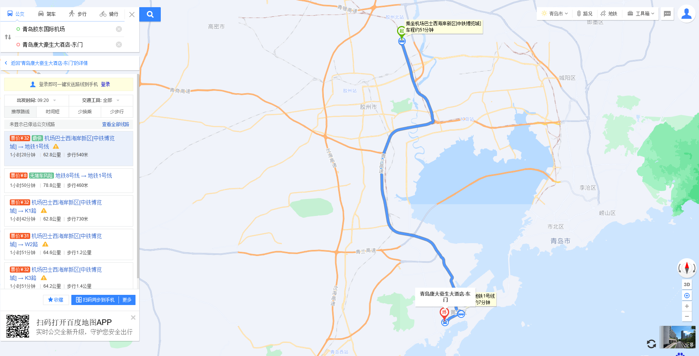
路线2：青岛站至酒店约23km，乘地铁1号线到石油大学地铁站A出口。打车约50分钟，60-70元。
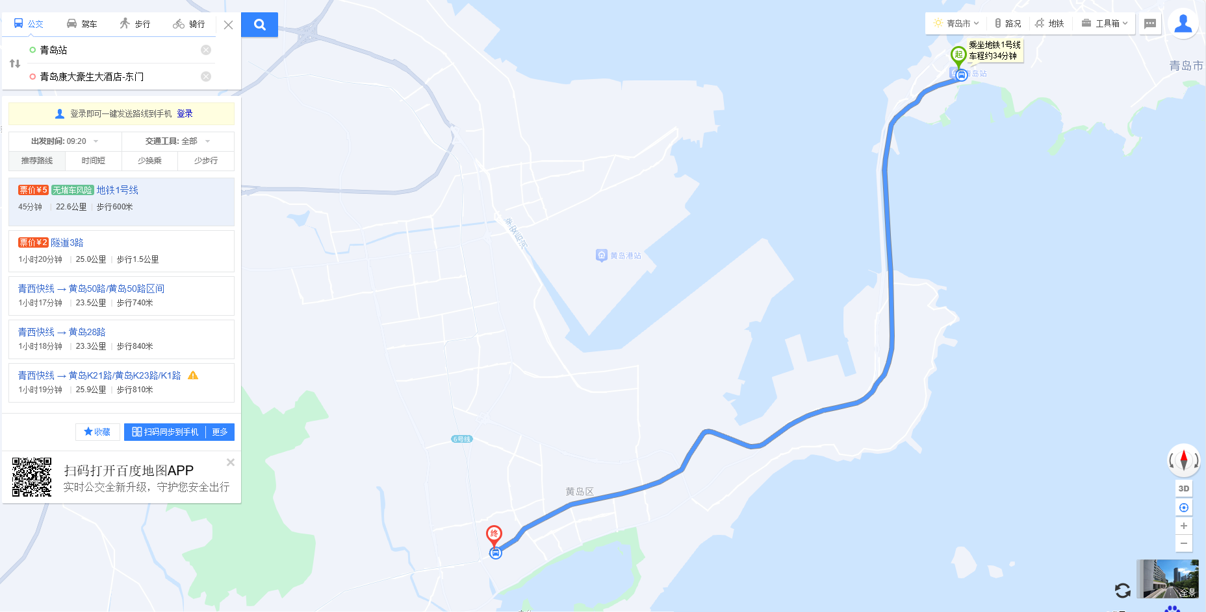
路线3：青岛北站至酒店约40km，乘地铁1号线到在石油大学地铁站A出口。打车约70分钟，120-150元。
